**Team #6**

Elsie Umukoro [Project Sponsor]

Ramya Krishnasamy[Project Manager]

Kunj Shah [Business Analyst]

Shubham Kiritkumar Thanki [Data Analyst]

Neha Lingampally [Financial Representative]

Shravani Soujanya Kodam [Documentation Expert]

Shourya Sahni [Quality Analyst]

CROWN BANK OF CANADA

Assignment 4 -As- Is Flow chart

02-15-2024

Table of Contents

Current Process Flow 3

Proposed Process Flow 6

RACI Matrix 9

References 9

## Current Process Flow

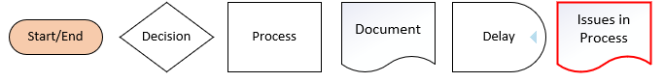

**Overview:**

In our loan processing system at Crown Bank of Canada, we've identified revenue loss as a significant challenge. This flowchart offers a detailed look into how revenue loss occurs across different phases of loan processing, from application to potential collection.

**Revenue Loss Analysis**

Our primary concern is revenue loss, which demands a closer examination to understand its underlying causes.

**Loan Initiation Phase**

During the initial phase, managed by the Sales Department, we collect documents and kickstart the application process. However, any delays or inaccuracies here could lead to revenue loss downstream.

**Credit Approval Phase**

The Credit Department's role in evaluating creditworthiness is pivotal. If we approve high-risk loans with adequate measures, such as adjusting interest rates or tightening repayment terms, we avoid facing increased defaults and revenue loss.

**Account Setup Phase**

As the Operations Department sets up accounts and disburses funds, errors in this phase, like misallocating funds or setting up incorrect repayment structures, can contribute to revenue loss. It's crucial to assess risks accurately during this stage to prevent unforeseen losses.

**Collection Phase**

Efficiency in the Collection Phase is crucial for mitigating revenue loss. Delays or inefficiencies in follow-up services can prolong recovery or lead to write-offs, amplifying revenue loss.

**Addressing Revenue Loss**

To address revenue loss effectively, we must optimize processes across all loan lifecycle stages. This could involve tightening documentation requirements, enhancing risk assessment protocols, improving account setup procedures, and streamlining collection processes.

**Conclusion**

While revenue loss poses a significant challenge, a systematic approach to process optimization and risk management can help mitigate this issue. By identifying and addressing potential sources of revenue loss, we can enhance our financial performance and ensure sustainable growth.

## Proposed Process Flow



**Overview:**

Our vision for enhancing Crown Bank of Canada's loan processing system focuses on streamlining operations and improving the customer experience. Our proposed changes introduce automation and personalized services across the four main phases: Loan Initiation, Credit Approval, Account Setup, and Collection.

**Loan Initiation Phase**

We're introducing semi-automated sales using bots to speed up customer interactions and document collection, ensuring a smoother start to the loan application process.

**Credit Approval Phase**

Automation is critical in this phase, where we aim for quicker credit decisions. Our personalized Credit Profiling will offer tailored borrowing costs based on thorough market analysis, promising more competitive interest rates and potentially increasing our market share.

**Accounts Setup Phase**

We're streamlining operations by semi-automating account setup, reducing manual workload, and enabling faster processing. Direct disbursement into user accounts will make the process more user-friendly and efficient.

**Collection Phase**

Flexibility is the name of the game here. We're introducing flexible payment terms to accommodate varying customer repayment abilities, which will reduce default rates. Automation will also significantly improve follow-up services and payment recording, providing advance notifications on EMIs to enhance customer service and streamline collections.

**Reducing Revenue Loss**

Our future state plan incorporates advanced automation and personalized services across the loan processing system, aimed at reducing revenue loss by enhancing operational efficiency, mitigating default risks, and improving customer engagement.

**Purpose and Presentation**

Designed for executive review, our strategic shift towards a more automated and customer-focused loan processing system aims to secure administrative support for our proposed changes. By showcasing anticipated improvements in operational efficiency, risk management, and customer service, this roadmap guides the technological upgrades and process re-engineering initiatives we plan to undertake.

(I have also published a Visio flow chart here.<https://stuconestogacon-my.sharepoint.com/:u:/g/personal/rkrishnasamy5844_conestogac_on_ca/EY_aJ03L3MZDu4iVDEKZkR4B69SmthKpAUpaLKhJYrPv2g?e=c1cTgo> )

## RACI Matrix

We have added a RACI (Responsible, Accountable, Consulted, and Informed) matrix to provide clarity on roles and responsibilities.

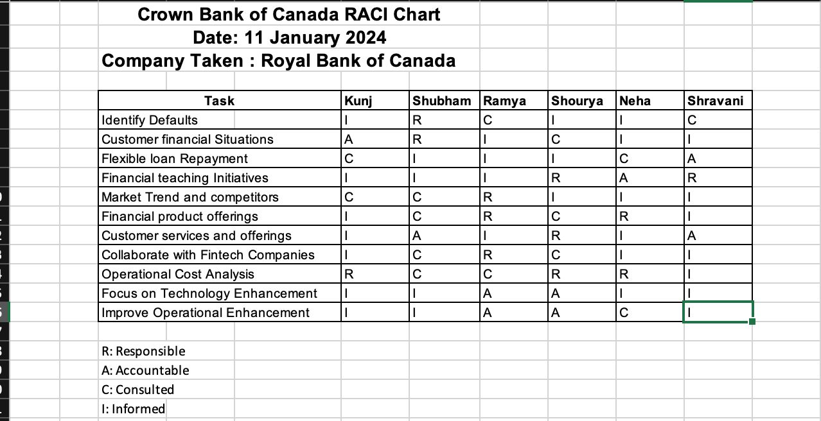

## References

1. Shields, P. (2024). A complete guide to as is and to be process mapping. Retrieved from <https://www.agilitysystem.net/insight/as-is-to-be-process-mapping/>
2. Retrieved from <https://stuconestogacon-my.sharepoint.com.mcas.ms/:u:/g/personal/rkrishnasamy5844_conestogac_on_ca/EY_aJ03L3MZDu4iVDEKZkR4B69SmthKpAUpaLKhJYrPv2g?e=c1cTgo>